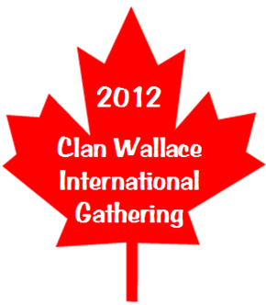
Clan Wallace Society Worldwide
International Gathering
August 30 – September 3, 2012
Calgary Alberta Canada

Host Hotel:

Sheraton Cavalier Hotel
2620 32nd Avenue, N.E.
Calgary, AB T1Y 6B8
403.250.6373

Group Name: Clan Wallace Society
Arrival Date: Thursday, August 30, 2012
Departure Date: Monday, September 3, 2012
Group Rate: Single: $129.00 Double: $129.00
Rates subject to 5% Goods & Services Tax, 4% Alberta Tourism Levy
& 3% Destination Marketing Fee (12% Total)
Rates are in Canadian Funds; est. $150 USD (taxes included) per Night
Attendees will make their own reservations and will be required to provide a credit card number or a deposit equal to one night’s room rate & taxes to guarantee the reservation.
Reservations: 1 403 291-0192 or groupres@sheratoncalgary.ca (identify Clan Wallace for rate)
Cut Off Date: July 29, 2012

Overlooking downtown Calgary and the Rocky Mountains, the newly renovated Sheraton is ideally located in the city’s suburban airport business district near local attractions, shopping and restaurants.

Hotel Amenities: Complimentary High-Speed Hardwire & Wireless Internet Access
Complimentary 24-hour extensive Fitness Facility
Indoor water park with swimming pool, two hot tubs & saunas
A variety of food & entertainment outlets, including:
Carver’s Steakhouse – Award winning dining, open nightly
Colors Café – Casual all-day dining with a diverse menu
Henry’s Pub – Relax & watch the game or shoot some pool
Lobby Lounge – Elegant atmosphere to enjoy hors d’oeuvres & cocktails
Rooms Service – Available 24 hours a day
A superb location – just 10 minutes from the airport & 10 minutes to Downtown
Downtown Calgary accessible via a Trolley Line
24-Hour airport shuttle service available ~ $5 Surcharge

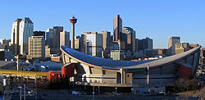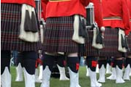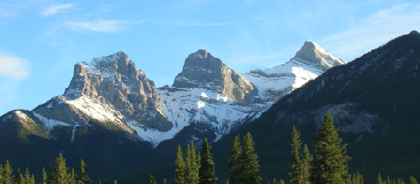
The 2012 Clan Wallace Society Worldwide International Gathering will be in conjunction with the Calgary Highland Games and the Canmore Highland Games. Calgary’s reputation as both a modern big city and a friendly wild western town allows Clan Wallace to experience the best of both worlds. Located just east of the world famous Banff Nation Park, and about 70 miles west of Calgary, is Canmore. This picturesque town from its humble beginnings as a coal mining town is now a popular year-round vacation travel and resort destination.

Both Calgary and Canmore Highland Games are one-day events, Saturday & Sunday respectively, and offer Clan Tents, Piping and Drumming Competitions, Highland Dancing, Heavy Sports, Vendors and much, much more.

The cost of the Games and their events are separate from the Gathering and their costs will be borne by the attendees. Transportation to the Games will be included in your Gathering registration.

The Calgary Highland Games ~ calgaryhighlandgames.org

Location: Springbank Park For All Season, just west of Calgary
Schedule: 7:30am Gates Open, Event Starts 8:30am with Closing Ceremonies at 5pm
Ticket Pricing*: Available Online & Gate
Adult: Online $12 / Gate $15
Seniors: Online $9 / Gate $10

The Canmore Highland Games ~ canmorehighlandgames.ca

Location: set in magnificent Canadian Rockies at Centennial Park
Schedule: 7am Gates Open, Event Starts 8am with Closing Ceremonies at 5pm
Ticket Pricing*: Available Online & Gate
Adult: $14
Seniors: $12

* 2011 Ticket pricing is in Canadian ~ please check websites for updated 2012 information and schedule of events

Tentative Schedule of Events:

Thursday, August 30, 2012
Afternoon Registration
Evening’s No Host informal gathering at Henry’s Pub within Host Hotel

Friday, August 31, 2012
Presentations & Free Time
Welcome Banquet Buffet & Cash Bar

Saturday, September 1, 2012
Calgary Games, via group travel / motor coach
Evening’s Whisky Tasting

Sunday, September 2, 2012
Canmore Games, via group travel / motor coach

Monday. September 3, 2012
Farewell Brunch Buffet

Gathering Menus

Welcome Banquet Buffet ~ Friday, August 31^{sr}

Garden Greens
Tossed Salad
House Dressing, French Dressing & Raspberry Vinaigrette
Marinated Mushroom Salad, Caesar Salad,
Oriental Salad

Vegetable Tray with Dill Dressing

Carved Triple A Roasted Alberta Baron of Beef
Herb Crusted Chicken Breast

Creamy Whipped Potatoes
Honey Glazed Carrots
Broccoli Milanese

Dessert Table:
Strawberry Mousse Torte, Carrot Cake
Almond Pear Flan, Strawberry Rhubarb Pie
Mini Crème Caramel, Nanaimo Bars
Chocolate Mousse Torte, Fruit Flan
Chocolate Butter Cream Torte

Fresh Rolls & Butter
Coffee & Tea

Cash Bar will be Available

Farewell Brunch Buffet ~ Monday, September 3rd

Fresh Chilled Fruit Juices
Medley of Seasonal Fresh Fruits
Bircher Muesli, Freshly Baked Buttery Croissants
Assorted Mini Danish, Assorted Muffins
Banana Bread, Buns & Butter
Domestic Cheeses

Salad Bar with:
Tossed Green Salad, Romaine Lettuce,
Baby Spinach, Croutons, Sunflower Seeds
Parmesan Cheese, Variety of Dressings
Potato Salad, Thai Salad, Vegetable Tray

Farm Fresh Scrambled Eggs
Ham, Bacon and Sausage
Hash Brown Potatoes

Carved Baron of Beef
Carved Honey Ham with Pineapple Sauce
Pasta with Salmon & Lemon Sauce

Array of Pastries and Cakes
Cavalier Ice Cream Sundae Bar with all the Trimmings
Strawberry & Blueberry Crêpes
Freshly Brewed Coffee, Decaffeinated Coffee & English Tea
2012 International Gathering of Clan Wallace Society Worldwide
Registration
March 30 ~ September 3, 2012
Calgary Alberta Canada

Checks and Money Orders Payable to Clan Wallace Society Worldwide
Completed form and payment must be received no later than August, 10, 2012 to:
Lisa Donant, Treasurer Clan Wallace Society Worldwide
7454 Plum Rose Court, Mechanicsville, Virginia 23111

Gathering Registration Fee per Person is just $150 for Clan Wallace Members & Guests

Registration Fee Includes:

Gathering Commemorative Souvenirs
Presentations
Welcome Banquet Buffet
Motor Coach Transportation to & from Calgary Highland Games
Whisky Tasting
Motor Coach Transportation to & from Canmore Highland Games
Farewell Brunch Buffet

Registration Fee Does Not Include:

Transportation to & from Calgary Airport (YYC)
Food & Beverage at Thursday’s Informal Gathering at Henry’s Pub
Transportation to Downtown area, maybe 10-15 minutes from Host Hotel
but accessible via Trolley Line
Admission to Calgary & Canmore Highland Games

Please fill out the bottom portion and return with payment

Name: ______________________________ # of Guests (if any) ____

______________________________ Names: _______________________

Address:______________________________ _______________________

______________________________ _______________________

Phone: ______________________________ _______________________

Email: ______________________________

Total of _____ Attendees @ $150 per Person

Enclosed $ __________

